INDEX

|  |  |  |
| --- | --- | --- |
| **S.NO.** | **CONTENT** | **PAGE NO.** |
| 1. | Introduction | 2 |
| 2. | Objective of Project | 3 |
| 3. | Problem Description | 4 |
| 4. | Feature and Benefits | 5 |
| 5. | Software Selection Criteria | 6 |
| 6. | System Analysis | 7 |
| 7. | Project Planning | 8-9 |
| 8. | Project Scheduling | 10 |
| 9. | Hardware/Software requirements | 11 |
| 11. | Gantt chart | 12-13 |
| 12. | Class Diagram | 14-15 |
| 13. | Research and development | 16 |
| 15. | Tour and packages | 17 |
| 14. | Future Scope and Enhancement | 18 |
| 15. | System Testing | 19-20 |
| 16. | Database connectivity | 21-23 |
| 17. | Conclusion | 24 |
| 18. | Bibliography | 25 |

1. **INTRODUCTION**

**“THE CAMP HILLS”** is a tour and travel agency that has recently came into existence with most affordable and valuable packages that most of us can afford. They have their specification in mostly tour, camping and trekking ventures and moreover they have their own camp site in BILING top and have a team of professional trekkers and guides across areas. The website was built on HTML, CSS, JAVASCRIPT was used, PHP and MySQL at back end. Full coding was done on VS-code with multiple accordion, cards, parallax and was out images were used. Bootstrap 5 frameworks were used along with bootstrap properties and multiple style sheets were used.

The website is basically very much user friendly, anybody who wants to travel to Himachal and explore new touched and explored tribes can definitely come and give its opinion explore this new place. We have our connections with local and native people providing them their monthly income with more input and more tourist.

The tourist gets to explore the new places and the local people helps to generate tourism and money. It becomes a cycle and the pain pass continues to roll and thus making it much more compatible to other big vendors in the market. It has no annual fees or any hidden charges all are transparent and up to the mark.

**2. OBJECTIVE OF PROJECT**

The main objective of **Travel and Trekking**  is to provide the information about all the small to small must visit places, things and most importantly make people aware that HIMACHAL PRADESH is one place where the are ample amount of resources, most unexplored place yet, the vision to see its beauty is almost beyond our imagination and thus promote tourism.

**Benefits**

Travelling and Trekking website provides user with a number of benefits, beyond the strict financial gains.

**Profile: -**User friendly profiles of websites are provided so that user feel homely and can easily download information without any problems.

**Feedback: -** User can also give feedback about their experience with our information if they like.

**Trainer: -** Trainer has access to upload the meaningful information and provide permission to user if the knowledge is free and extensible.

**3. PROBLEM DESCRIPTION**

The camping monk came into existence during lockdown to serve local people with tourist and localide culture. Earlier the whole work was done telephonically and with other resources but now this came to online platform

We provide all travel and stay in anywhere within Himachal Pradesh. There is option for quite reasonable rates for bus booking, train booking, flight booking and moreover hotel booking.

Earlier people were unable to see and search for many places in Himachal where there is hardly any knowledge about some extreme adventures present here.

The main problem was:-

1. Lack of knowledge
2. Practicality in rates
3. Proper description
4. Stay facilities
5. Offline records
6. Maintenance

**4. FEATURES AND BENEFITS**

# The features and benefits are as following:

* 1. Project and component based.
  2. Query issue list in depth.
  3. Creating and changing issues are easy.
  4. Two way communication
  5. Simple status and resolution.
  6. Multi-level priorities & severities.
  7. Robust database back-end.
  8. No third party interference.
  9. Accuracy in work.
  10. Well – designed reports.
  11. Access of any information individually.
  12. Easy to update information.
  13. Work becomes very easy.
  14. Knowledge about their work.
  15. Feedback status is quite fast.
  16. Contact-full conversation.
  17. Professionalism

**5. SOFTWARE SELECTION CRITERIA**

Software’s are selected by keeping in mind following criteria:

1. Software practicality
2. Open source software
3. User friendly
4. Support services
5. Speed up the development process

## 1. Software practicality. Software selection for the development purpose must be useful i.e. it must help the developer in the software development process.

## 2. Open source software. Most of the software’s used in the development process are open source as open source software’s can be changed or altered as per our needs without having to pay for their usage.

**3. User friendly:-** the software should be user friendly and show be approachable means that if any changes to be made can be done quite easily and affectively.

## 4. Support sources. Software’s selected for development processes have a wide support service like forms, chat rooms, and live chat support worldwide.

## 5. Speed up the development process. Software selected for development process speed up the development process as it generates the code automatically wherever possible.

**6. SYSTEM ANALYSIS**

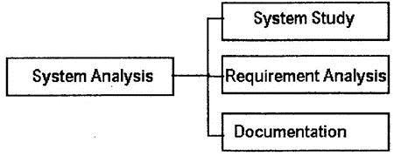

1. **System study**: The system study is information-oriented stage in which user; middlelevel and higher-level management have to face interviews.
2. **Interview**: The system analysis team conducts face-to-face interview with thestaff of organization.
3. **Questionnaire**: distribute questions (closed, open, probing types) to user and notetheir responses.
4. **Observation**: The actual position of men and machine are observed on-site.
5. Study of literatures, objective of organization, procedural manual etc is important tools for data collection.
6. **Requirement analysis**: The user expectation with new or candidate system is called userrequirement. The requirement can be qualitative and quantitative.
7. **Documentation**: The report of system study and requirement analysis is studied anddocumented. Designer team for system designing uses this document. If document does not contain appropriate information, design cannot be successful.

**7. Project Planning**

# FEASIBILITY STUDY: The feasibility study is undertaken to determine the possibility of either improving the present system or developing a completely new system. It helps to obtain an overview of the problem and get an idea whether a feasible solution exists.

# Operational Feasibility Study: The current system is manual. Thus processing large amount of data becomes a cumbersome activity. Reports that are generated are difficult to prepare manually and are also error prone. Operationally the Proposed system is feasibility because there are sufficient supports for project from management. It will be running smoother and faster that of existing system.

# Technical Feasibility Study: Generally, new system brings new technology into an organization. The proposed system requires technology and equipment, which can be obtained. the operating system has the technical capacity to hold the data required to use the proposed system. The present equipment technology assures technical guarantee of accuracy, reliability and ease of access.

# Legal/Ethical Feasibility Study: Determines whether the proposed system conflicts with legal requirements.

# Schedule Feasibility Study: A project will fail if it takes too long to be completed before it is useful. Typically this means estimating how long the system will take to develop, and if it can be completed in given time period using some methods like payback period. Schedule feasibility is a measure of how reasonable the project timetable is. Given our technical expertise, are the project deadlines reasonable? Some projects are initiated with specific deadlines. You need to determine whether the deadlines are mandatory or desirable.

# Resource Feasibility Study: This involves questions such as how much time is available to built the new system, when it can be built, whether it interferes with normal business operations, type and amount of resources required, dependencies.

# Cultural Feasibility Study: In this stage, the project's alternatives are evaluated for their impact on the local and generated culture. For example, environmental factors need to be considered and these factors are to be well known.

**8. PROJECT SCHEDULING**

# Scheduling in project management is the listing of activities, deliverables, and milestones within a project. A schedule also usually includes a planned start and finish date, duration, and [resources](https://www.wrike.com/use-cases/resource-management/) assigned to each activity.

# There are three main types of project schedules:

# Master project schedule: A [master schedule](https://www.pmi.org/learning/library/fundamentals-master-scheduling-project-manager-1809) tends to be a simplified list of tasks with a timeline or project calendar that the work can be completed within the time limit so that no extra cost occurs.

# Milestone schedule or summary schedule: This type of project schedule tracks major milestones and key deliverables, but not every task is required to complete the project. During the development phase if any module is left or is misplaced all things are kept in mind thus work is done.

# A detailed project schedule: This is the most thorough project schedule, as it identifies and tracks every project activity. If you have a [complex](https://www.wrike.com/templates/complex-project-with-phases/), large, or lengthy project, it’s important to have a detailed project schedule to help track everything. With proper record and teamwork work assigned can be completed within the time limit.

# Hardware/Software requirements

**Minimum Hardware Requirements:**

Processor: Core i5-10500h

RAM: 8 GB RAM

Graphic card: GTX 1650 - 4GB

Hard Disk: 100MB Free Hard disk space

Monitor: IPS level 144 Hz super thin

**Software Requirements**

Operating System: Windows: 11 OS

Family Software: Java Database, MySQL, VS-Code

# 10. GANTT CHART

A Gantt chart is a project management tool that illustrates a project plan. It typically includes two sections: the left side outlines a list of tasks, while the right side has a timeline with schedule bars that visualize work. The Gantt chart can also include the start and end dates of tasks, milestones, dependencies between tasks, and assignees. To keep up with the demands of modern software development, roadmap tools like Jira Software include features like a collapsible task structure and resource management panels.

What is a Gantt chart used for?

Project managers use Gantt charts for three main reasons:

**Build and manage a comprehensive project**

Gantt charts visualize the building blocks of a project and organize it into smaller, more manageable tasks. The resulting small tasks are scheduled on the Gantt chart's timeline, along with dependencies between tasks, assignees, and milestones.

**Determine logistics and task dependencies**

Gantt charts can be employed to keep an eye on the logistics of a project. Task dependencies ensure that a new task can only start once another task is completed. If a task is delayed (it happens to the best of us), then dependent issues are automatically rescheduled. This can be especially useful when planning in a multi-team environment.

**Monitor progress of a project**

As teams log time towards issues in your plan, you can monitor the health of your projects and make adjustments as necessary. Your Gantt chart can include release dates, milestones, or other important metrics to track your project’s progress.

**The benefits of using a Gantt chart**

There are two main reasons why Gantt charts are loved throughout the project management world. They make it easier to create complicated plans, especially those that involve multiple teams and changing deadlines. Gantt charts help teams to plan work around deadlines and properly allocate resources.

Projects planners also use Gantt charts to maintain a bird’s eye view of projects. They depict, among other things, the relationship between the start and end dates of tasks, milestones, and dependent tasks. Modern Gantt chart programs such as Jira Software with Roadmaps and Advanced Roadmaps synthesize information and illustrate how choices impact deadlines

# 11. Class Diagram

# 

Class diagram is a static diagram. It represents the static view of an application. Class diagram is not only used for visualizing, describing, and documenting different aspects of a system but also for constructing executable code of the software application.

Class diagram describes the attributes and operations of a class and also the constraints imposed on the system. The class diagrams are widely used in the modeling of objectoriented systems because they are the only UML diagrams, which can be mapped directly with object-oriented languages

Purpose of Class Diagrams

The purpose of class diagram is to model the static view of an application. Class diagrams are the only diagrams which can be directly mapped with object-oriented languages and thus widely used at the time of construction.

UML diagrams like activity diagram, sequence diagram can only give the sequence flow of the application, however class diagram is a bit different. It is the most popular UML diagram in the coder community.

The purpose of the class diagram can be summarized as −

Analysis and design of the static view of an application.

Describe responsibilities of a system.

Base for component and deployment diagrams.

Forward and reverse engineering.

# 12. Research and development

The complete R&D was done that was done from various websites and what all things are needed in the website.

# What all components will be used?

# What all methods will be used

# Card properties

# Layouts

# Parallax method

# Design algorithm

# Index

# Navbar display format

# Css file

# Connectivity

# Layout

# Media

# Images

# Location

# 13. Tour and packages

# As we are currently very new to the online market and we have been in offline market for quite a long time this has made us with a conclusion that there is hardly and travel company that has its own camping areas within several different locations in the state and we provide people with most extreme travel plans and expenditures that hardly many of the other people are involved in.

# We provide:-killar kishtwar package

# Tirthan valley package

# Dharamshala package

# Leh-ladakh package

# Spiti packages

# Etc..

# with full itenary and proper planning , guide and recovery team so that any of our clients have no problem regarding their travel.

# 14. Future Scope and Enhancements

# There will be further more changes done to the website as per user demands.

# Various new sections will be introduced.

# More images will be done and made separate sections for it.

# Database will be highly collaborated and effective.

# Website will be updated in a particular instance of time.

# People will be able to add their photos and upload them to user view.

# Timely notifications will be transferred.

# Spam mails won’t exist.

# New offers will be given on time to time basis.

**15. SYSTEM TESTING**

**System Testing** is a level of testing that validates the complete and fully integrated software product. The purpose of a system test is to evaluate the end-to-end system specifications. Usually, the software is only one element of a larger computer-based system.

The goal of integration testing is to detect any irregularity between the units that are integrated together. System testing detects defects within both the integrated units and the whole system. The result of system testing is the observed behavior of a component or a system when it is tested. System Testing is carried out on the whole system in the context of either system requirement specifications or functional requirement specifications or in the context of both. System testing tests the design and behavior of the system and also the expectations of the customer. It is performed to test the system beyond the bounds mentioned in the software requirements specification (SRS).

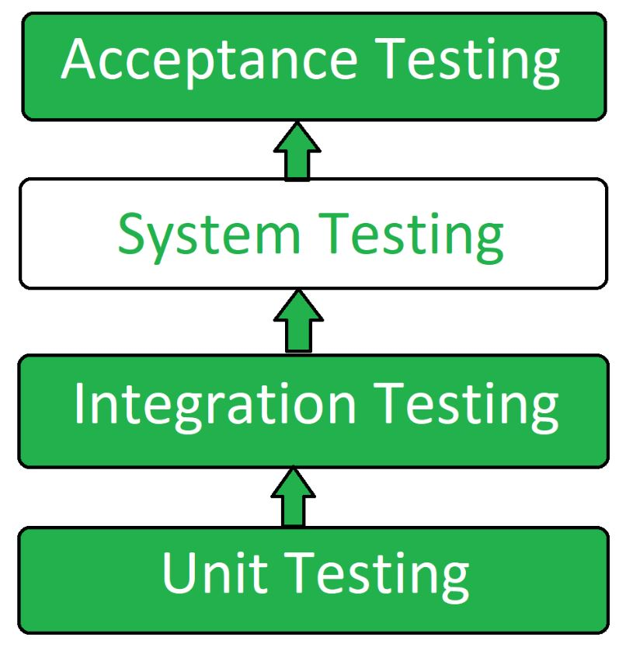

**System Testing Process: System Testing is performed in the following steps:**

**Test Environment Setup**: Create test environment for the better quality test.

**Create Test Case:** Generate test case for the testing process.

**Create Test Data:** Create the data that is to be tested.

**Execute Test Case**: After the creation of the test case and the test data, test cases are executed one by one.

**Defect Reports:** Defects in the system are detected and executed and then solved.

**Regression Testing**: It is carried out to test the side effects of the testing process.

Log Defects: Defects are fixed in this step.

Retest: If the test is not successful then again test is performed.

**Types of System Testing:**

**Performance Testing**: Performance testing is a type of software testing that is carried out to test the speed, scalability, stability and reliability of the website.

**Load Testing**: Load Testing is a type of testing which is carried out to determine the behavior of a system or software product under extreme load.

**Stress Testing**: Stress testing is a type of software testing performed to check the robustness of the system under the varying loads.

**Scalability Testing**: Scalability Testing is a type of software testing which is carried out to check the performance of a software application or system in terms of its capability to scale up or scale down the number of user request load.

**16. DATABASE AND CONNECTIVITY**

The database connectivity is the main and most important step to keep the record of what all reservations are made and what all changes are to be done.

**How to create database**

A database is a structured set of organized data. In the IT field, [**database management systems (DBMS)**](https://www.hostinger.in/tutorials/dbms)refer to software that interacts with a user, data, and retrieve and store data.

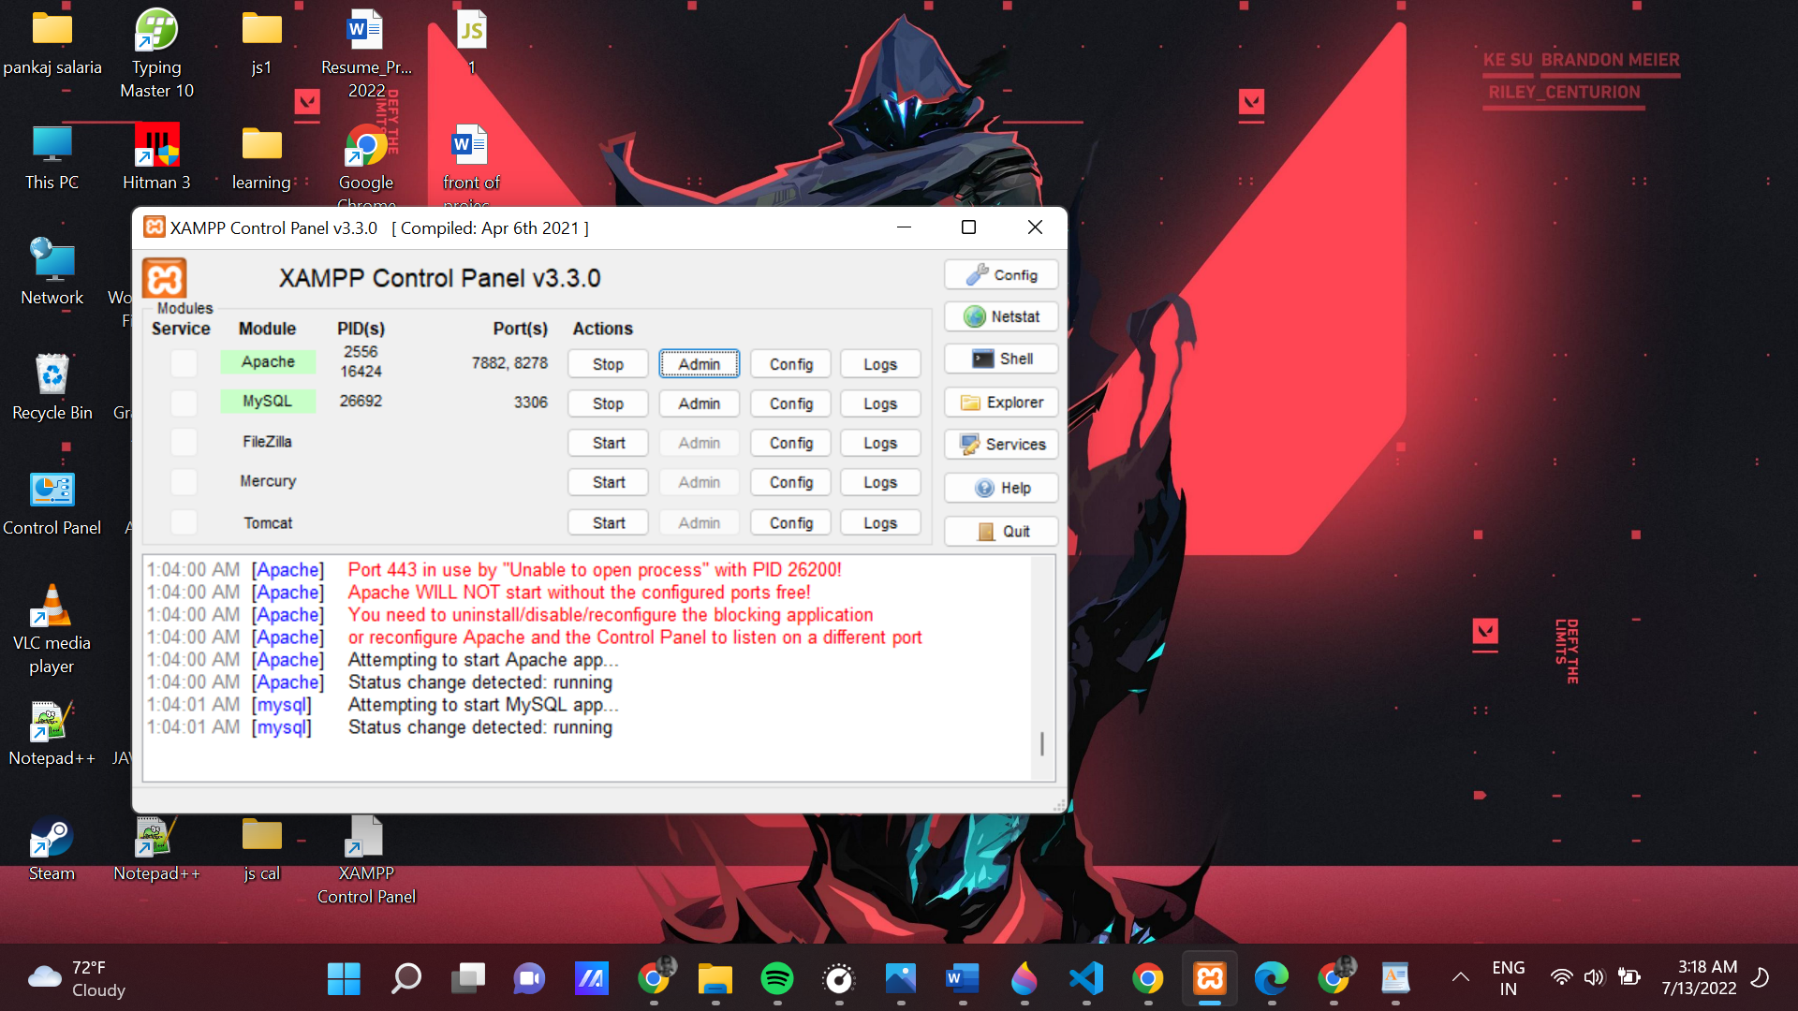

Create a MySQL database

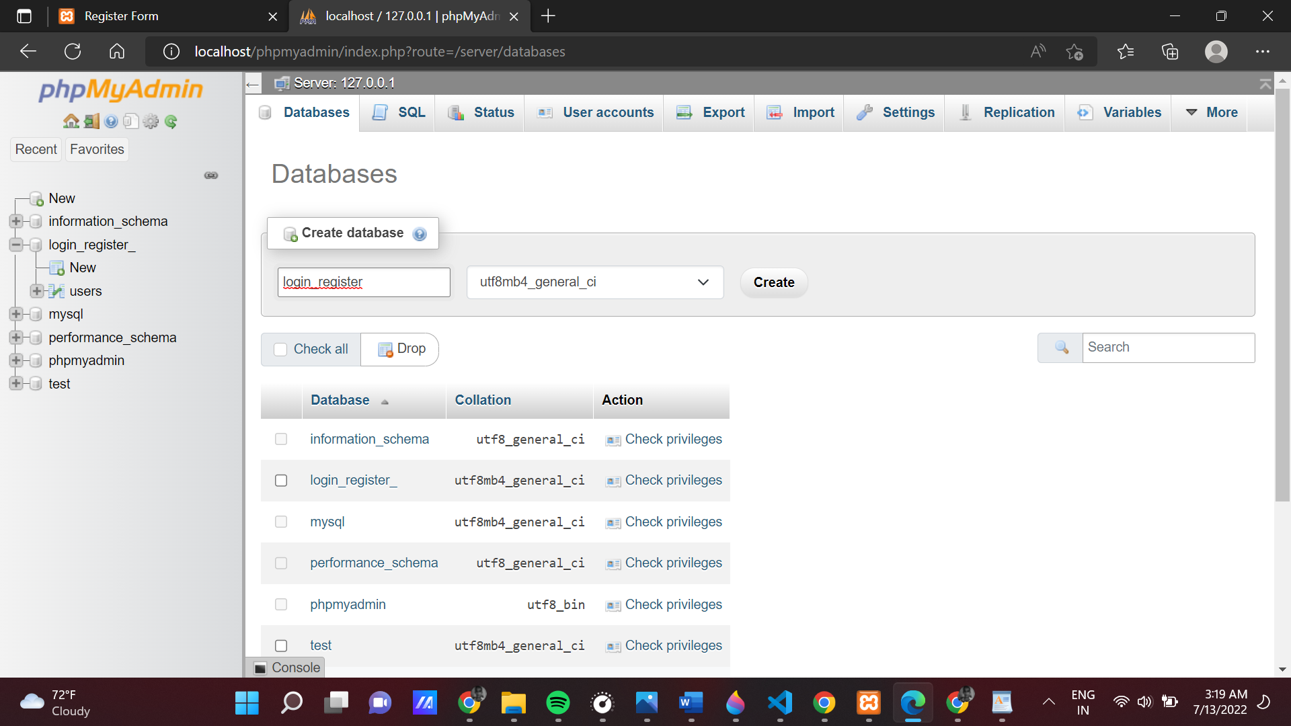

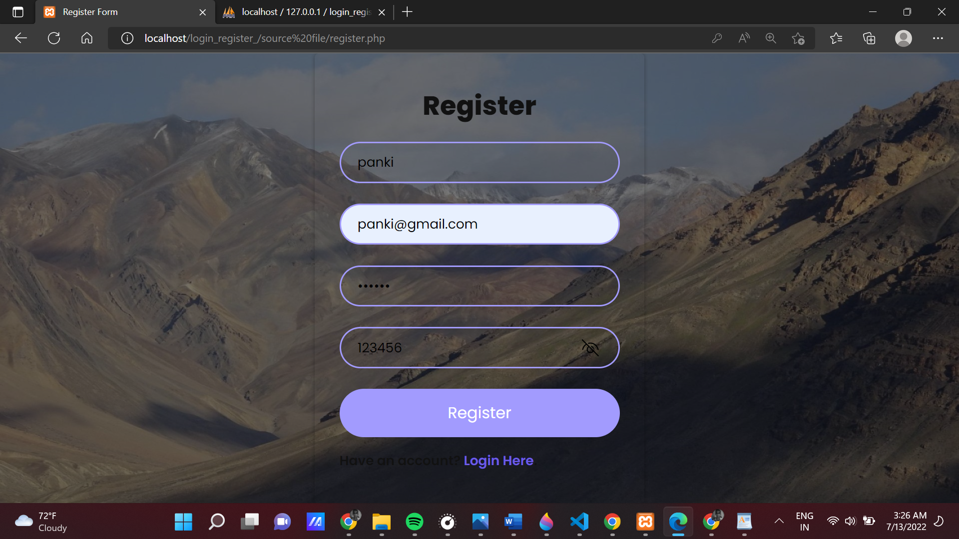

Hotel reservation

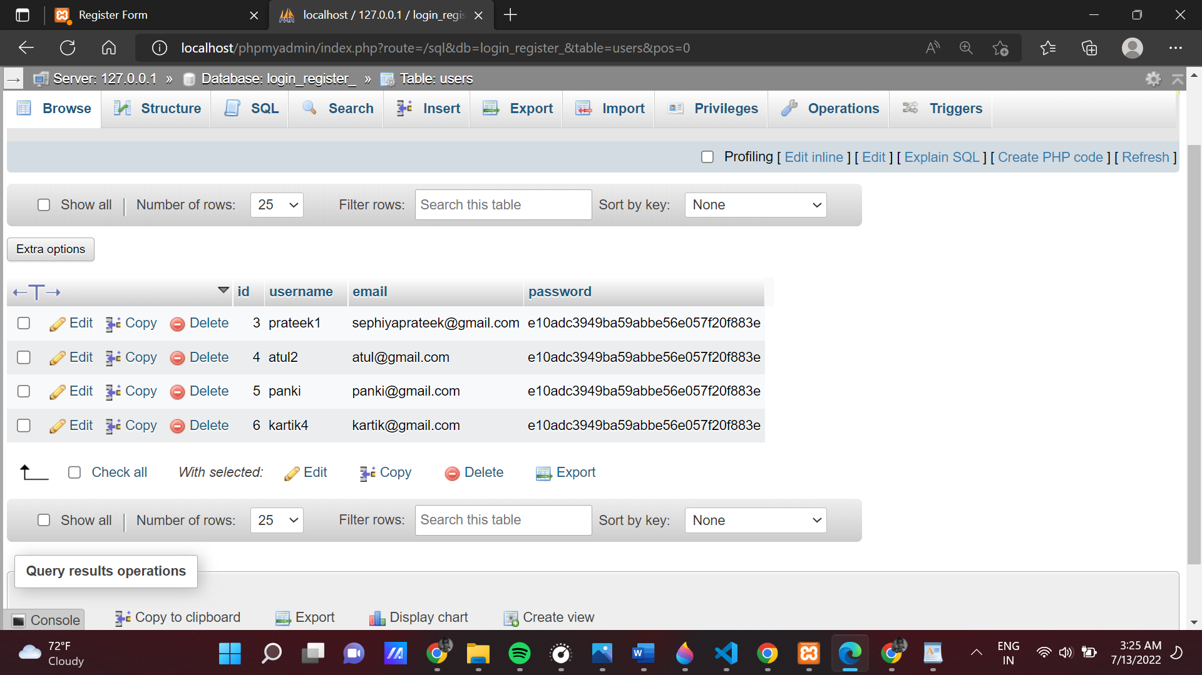

We can clearly see what is the id of the people and their registeration booking from date to time

**17. CONCLUSION**

The project as a whole describes the scope and viability of the travel indusry and mainly of the financial, technical and its market potential. The project guarantee sufficient fund to repay the loan and also give a good return on capital investment. When analyzing the social- economic impact, this project is able to generate an employment of 5 and above.

It will cater the demand in travel forum and thus helps the other business entities to increase the production and service which provide service and support to this industry.

Thus more cyclic employment and livelihood generation. So in all ways, we can conclude the project is technically and socially viable and commercially sound too. More growth of the organization means more growth of the people around it.

**18. BIBLIOGRAPHY**

# Get bootstrap5 for designing purpose.

# W3schools for learning.

# Shopify for new ideas and creations.

# GeekforGeeks for content and code related ideas.

# Fontawesome for various fonts and icons.

# VS-Code for live server and designing.

# MS-WORD for documentation.